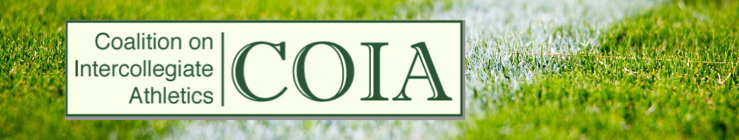

May 6, 2022

The Coalition on Intercollegiate Athletics (COIA) is an organization representing the elected faculty governance bodies of National Collegiate Athletic Association (NCAA) Division I universities in activities related to the administration and governance of intercollegiate athletics. COIA’s mission is to promote the academic integrity of member universities, and to represent the interests of faculties, student-athletes and non-athlete students in matters related to college sports that can significantly affect the health, sustainability, and educational missions of our institutions. One of COIA’s aims is to partner with faculty peers and other organizations on our common interests so we can provide a constructive, responsible, and informed representative faculty voice at each of our respective institutions, within the various athletics conferences and at the national (NCAA) level.
In relation to our aims and mission, COIA supports the goal of the C.A.R.E. model of the Knight Commission on Intercollegiate Athletics (https://www.knightcommission.org/), which serves to Connect Athletics Revenues with the Educational Model of College Sports (https://www.knightcommission.org/wp-content/uploads/2021/09/CAREModel.pdf). The proposed financial model includes transparency in revenue and gender/ethnicity demographics; independent oversight (but not, in our view, sufficient independent faculty oversight) on approval of revenue plans and compliance with principles; gender equity in athletics; availability of broad sports opportunities; and most importantly, fiscal responsibility for the education, health, and safety of student-athletes. Higher education and athletics on university campuses are not mutually exclusive, they are joined together to promote the academic success, health, and well-being of all students.
We encourage Faculty Senates to play an active role in athletics decisions through faculty governance, and to monitor the impact of these potential changes on their institutions and the lives of student-athletes.

